**HOW TO INSTALL MAVEN ON OUR PC**

1. Download jdk java lalu install

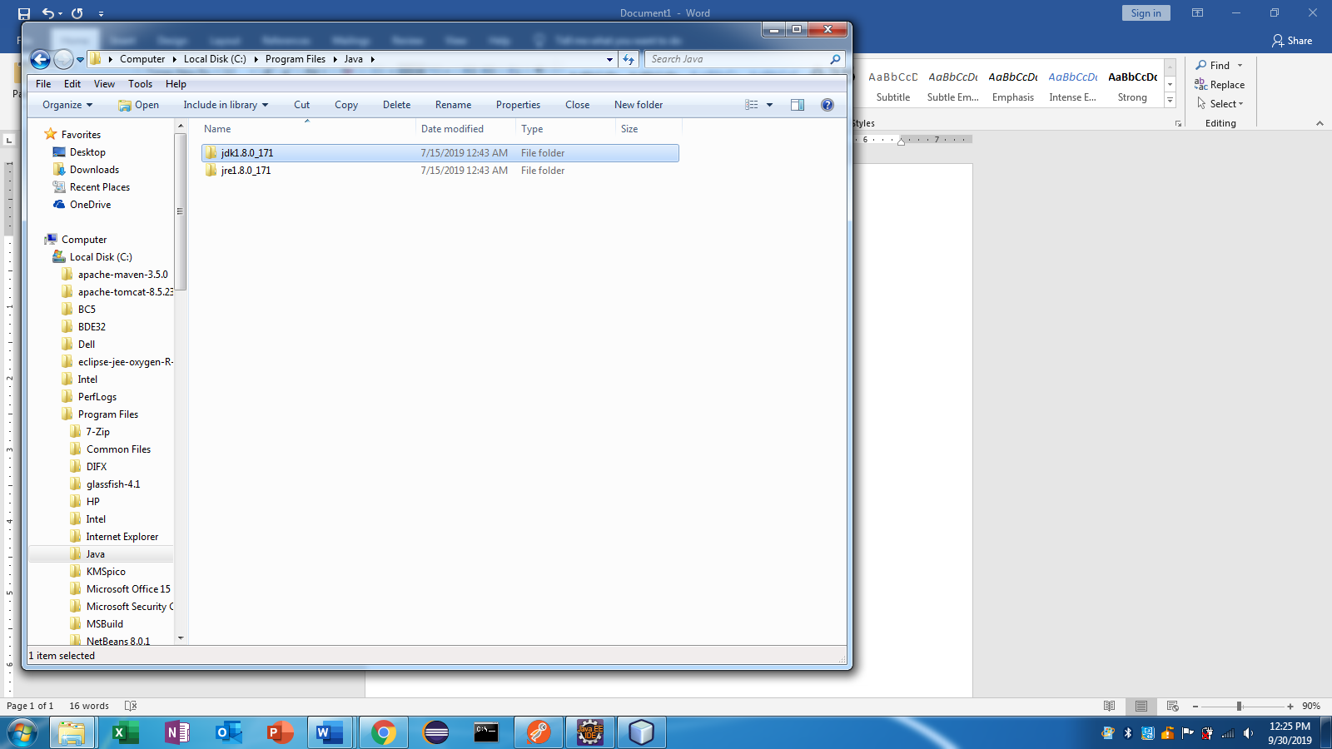

1. Cek jdk di pc kita. Buka cmd lalu ketik java -version

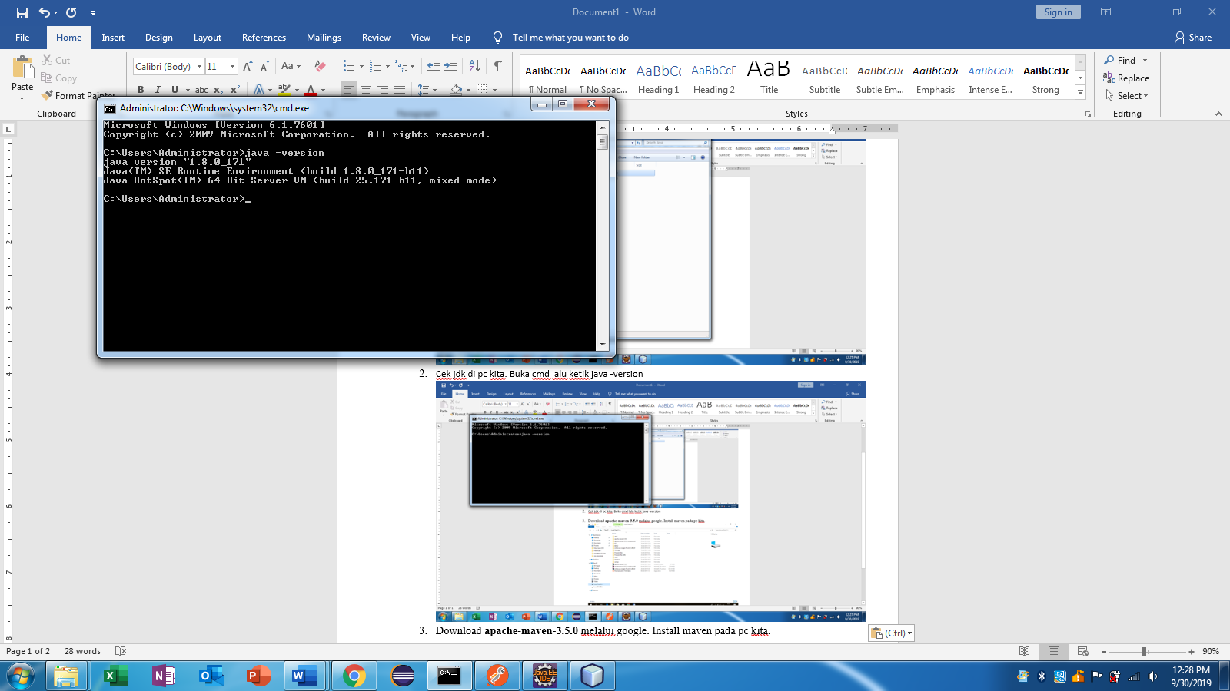

1. Setting path untuk java/jdk. Control panel – system and security – system – advanced system settings - Klik environment variable - Pilih kolom user variable

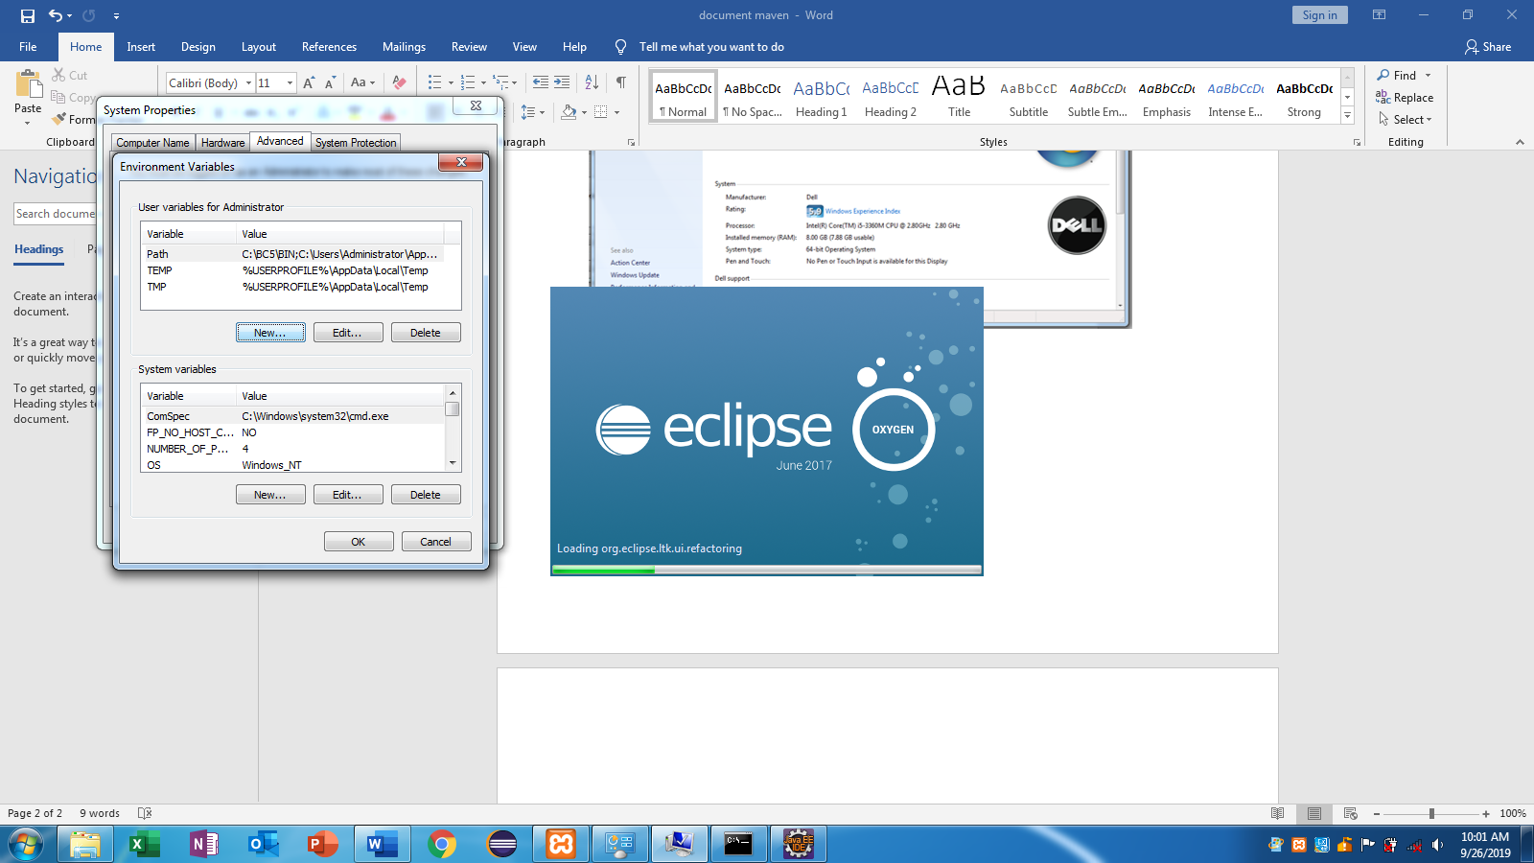

1. Klik button NEW. Isi di kolom variable name : JAVA_HOME

Isi di kolom variable value : C:\Program Files\Java\jdk1.8.0_171(direktori jdk di pc kita)

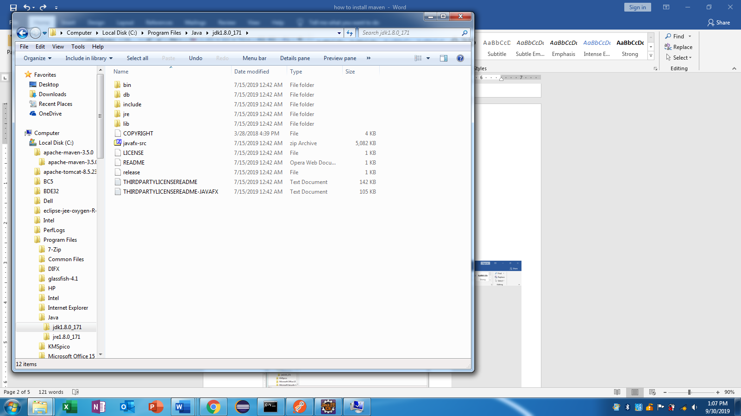

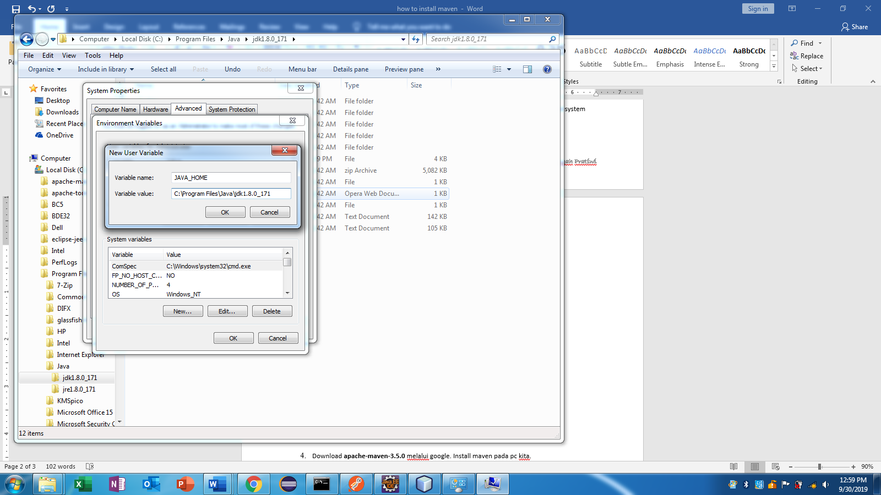

1. Klik pada variable path. Lalu klik button EDIT – variable path, tambahkan alamat C:\Program Files\Java\jdk1.8.0_171\bin;

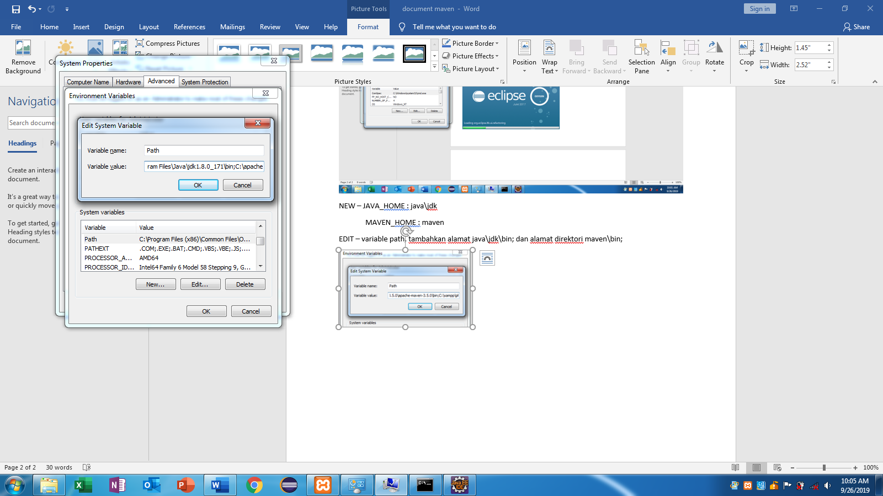

1. Download **apache-maven-3.5.0** melalui google. Install maven pada pc kita.

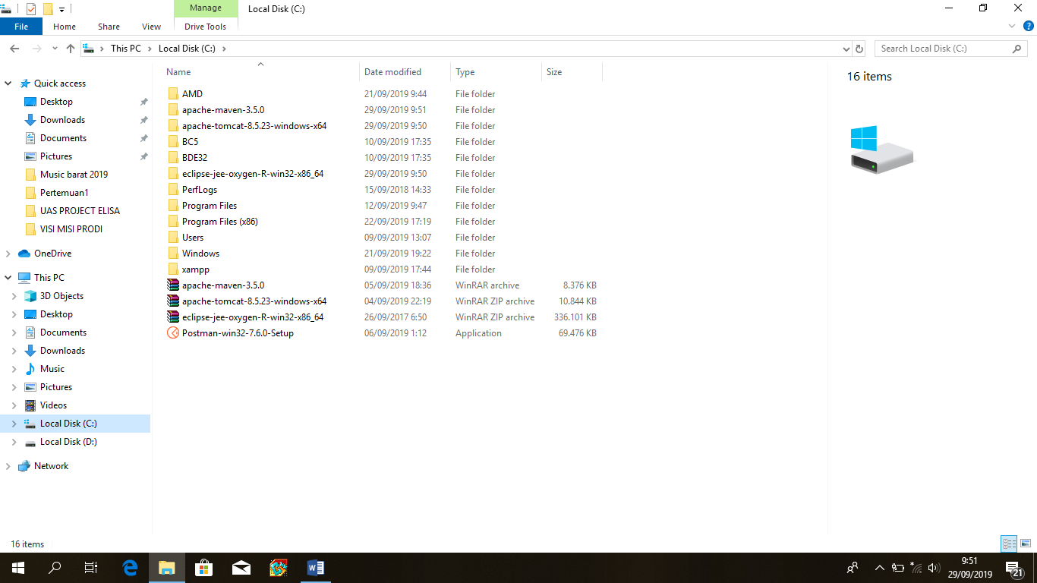

1. Setting path maven. Control panel – system and security – system – advanced system settings - Klik environment variable - Pilih kolom user variable



1. Klik button NEW. Lalu isikan pada kolom variable name: MAVEN_HOME

Isi pada kolom variable value : C:\apache-maven-3.5.0\apache-maven-3.5.0(direktori penyimpanan file maven di pc)

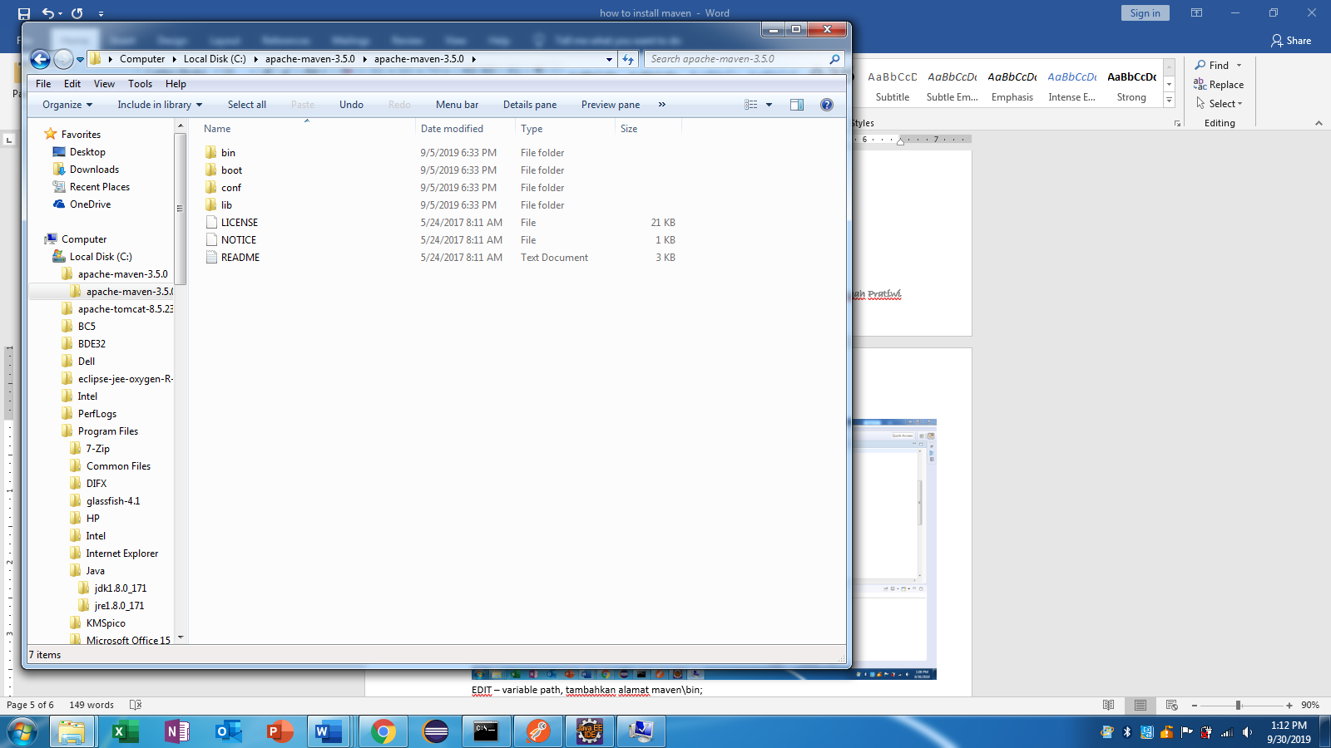

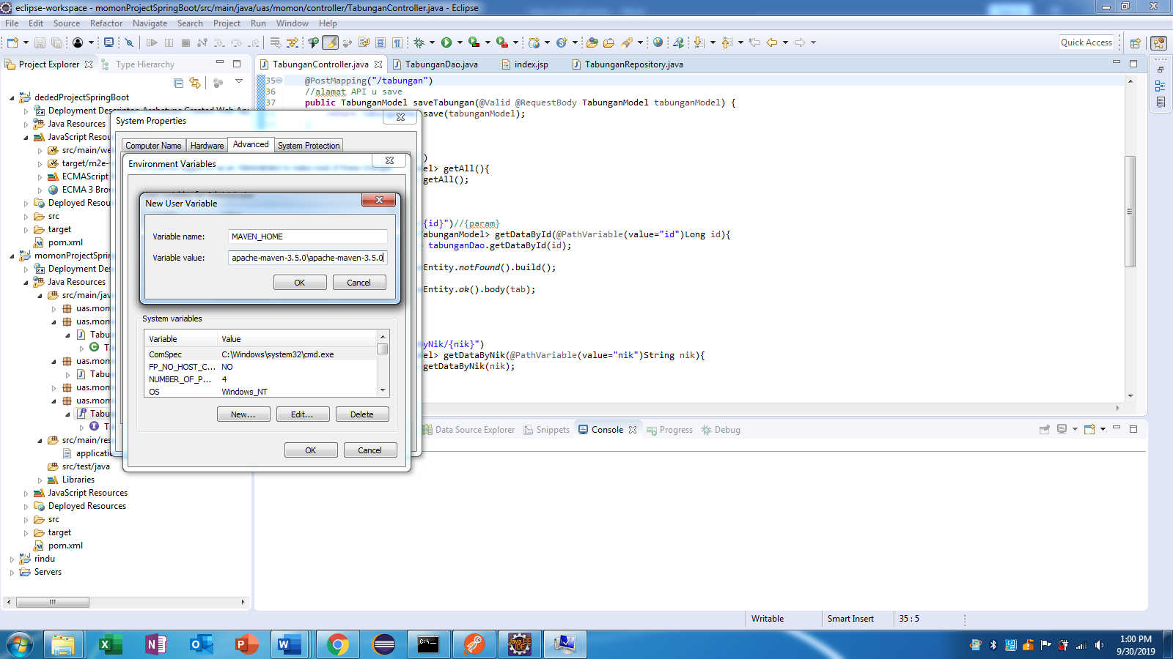

1. Klik pada variable path. Lalu klik butoon EDIT – variable path, tambahkan alamat C:\apache-maven-3.5.0\apache-maven-3.5.0\bin;

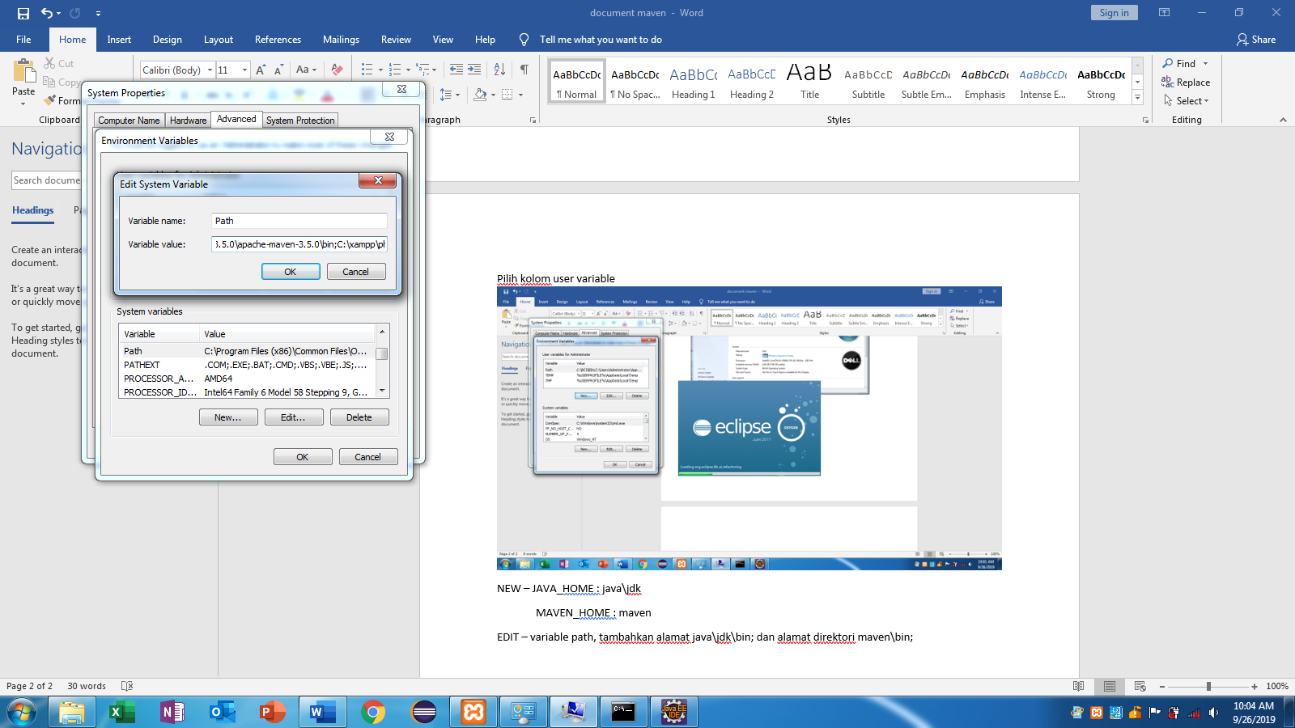

10. Cek maven melalui cmd. Lalu ketik mvn -v

